Pilates 1901 is Moving! Here’s the 411.
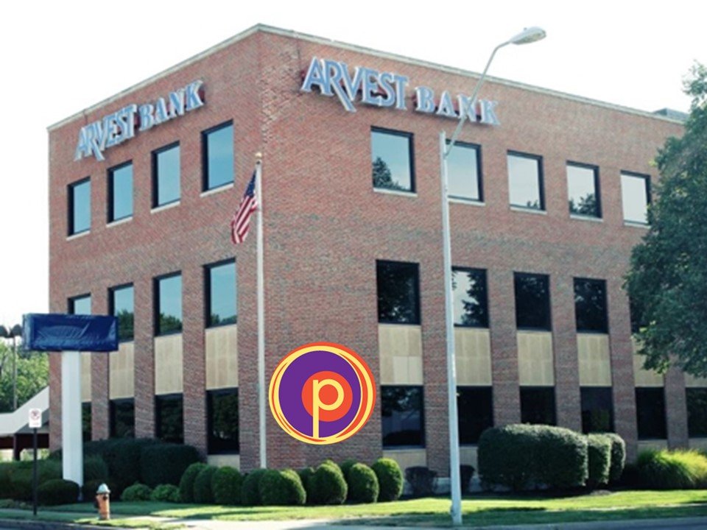
Conveniently located at Gregory and Wornall Roads
_______________________________________________________________
Where are we moving?
222 West Gregory (the NE corner of Gregory (71st) & Wornall Roads in the Arvest Bank Building.

What is the parking like?
Great! The building has a large, easy parking lot that is also well lit at night!
When are we moving?
Renovations in new space are scheduled to be done May 8-10th. Our plan is to move that weekend if possible, but we will keep you posted!

Will I still get to do private training with my trainer?
Yes! The new studio has two furnished private training rooms as well as a large,
open studio for privates and small group training. You’ll still book with your
individual trainer according to your needs and schedule.

Will I still be able to do group classes?
Yes! You’ll still enjoy the same quality instruction and program variety in group classes which will now be called Small Group Training in Mind Body. The workouts are now all under one pricing option, so you have even more opportunity to benefit from our Small Group Reformer, Tramp, Tower, Mat, Inversion Therapy, and Yamuna Ball Rolling workouts. The schedule will be updated in Mind Body for reservations very soon.
Will I lose Small Group or Private Training sessions?
Of course not! Any sessions you have already paid for are valid at the new 1901 location.

Are Small Group Training prices going up?
We will be raising rates, however, as a valued client of Pilates 1901, you’ll have the opportunity to lock in your current rate when you renew your current 6-month package before June 30th Our new monthly flex packages allow you the greatest flexibility to schedule workouts around work, travel and family life. When you sign up for our best value, our 6-month Small Group Training pass, you’ll not only save big, but be able to reserve your favorite workouts up to 6 months in advance. Please refer to current client pricing rate box below.**

New Small Group Training Pricing

30-day Expiration Flex Packages for Small Group Training (Use them or lose them)
(Includes ALL Small Group Training Sessions on the Schedule)

- Intro Offer (five Sessions) $50
- Single Session $25
- 5 Sessions $100 ($20 per session)
- 10 Sessions $150 ($15 per session)
- 15 Sessions $199 ($13 per session
**Current Clients 180-day Expiration Small Group Training packages
- 90 Sessions ($8.60 per session) $129 per month for 6 months
- 120 sessions ($8.45 per session) $169 per month for 6 months

180-day Expiration Small Group Training Package (6-month contract)
- 120 Sessions ($12.45 per session) $249 per month for 6 months
What equipment will be at the new studio?
7 Tower Machines 1 Cadillac
- V2 Max Machines 6 Chairs
7 Arc Barrels 6-8 Hammocks
1 Spine Corrector Miscellaneous small props/mats

Are you selling any Pilates equipment?
Yes, we’re selling 7 reformers which come with a box, platform extender and jump board for $999. Other equipment for sale includes a Cadillac, Spine Corrector, Ladder Barrel, Steps & Misc. props. Office equipment, filing cabinets, bulletin boards, a projector & screen are also available. Please email us at info@pilates1901.com for more information.

Thank you and we appreciate your support and patronage during this transition! Please let us know if you have any questions. We look forward to showing you our new space in May! Our Open House TBA! Tina, Lisa & Team

